# Version: July 26, 2018

# **Water Quality Valuation Study**

This survey asks you about quality of water in fresh-water bodies or natural waterways such as rivers, streams, and lakes in and around your county. Through this survey, we would like to understand what you think about the quality of water in these water bodies or natural waterways and how valuable potential changes in the quality of water in rivers and streams are to you and your household. Please answer all the questions in this survey thoughtfully.

# 

|  |  |
| --- | --- |
| https://brand.uconn.edu/wp-content/uploads/sites/1060/2014/12/oak-leaf1.jpg  https://brand.uconn.edu/wp-content/uploads/sites/1060/2014/12/uconn-blue-stacked.jpg | Image result for epa logo |

# **SECTION I: GENERAL BACKGROUND QUESTIONS**

**S1_Q1. What inland, natural waterways (rivers, streams, or lakes) are there in your county? (tick all that apply)**

* River (1)
* Stream (2)
* Lake/Pond (3)
* Canal (4)
* Freshwater Wetland (5)
* Other _____________ (6)

**S1_Q2a. Approximately, how far is the closest natural waterway from your home (distance in miles)?**

--------------------------

**S1_Q2b. Approximately, how far is the closest natural waterway from your home (drive time in minutes)?**

--------------------------

**S1_Q3. On average, how often do you see or visit a natural waterway or body of fresh water?**

* Daily (1)
* Not daily but more than once a week (2)
* Weekly (3)
* Not weekly but more than once a month (4)
* Monthly (5)
* Less than once a month (6)
* Never (7)

**S1_Q4. What do you think of the overall quality of water in natural waterways in your county?**

* Not safe for human use
* Severely polluted
* Boatable
* Fishable but not consumable
* Improved fishing and better catches
* Barely swimmable or wadable (adequate for direct contact)
* Swimmable or wadable (suitable for direct contact)
* Drinkable (with minor treatment) and supports all human use

**S1_Q5. How do you rate the overall quality of water in natural waterways in your county for its role in supporting natural ecosystems or fish, wildlife, and native plants?**

* Supports nearly all native species of aquatic life (75-100%)
* Supports a 50-75% of native species
* Supports some native species (25-50%)
* Supports relatively few native species (up to 25%)
* Supports nearly no species (less than 5%)

**S1_Q6. Does your household currently pay any environmentally-related taxes or fees as part of your water, electric or other utility bills?**

* Yes (1) If yes, please describe them: _________________________________________
* No (2)
* Don't know (999)

**S1:Q7. How do you rate the quality of water in natural waterways (rivers, streams, or lakes) in your county in following dimensions?**

|  |  |  |  |  |  |  |  |
| --- | --- | --- | --- | --- | --- | --- | --- |
|  | Extremely good (1) | Good (2) | Somewhat good (3) | Neither good nor bad (4) | Somewhat bad (5) | Bad (6) | Extremely bad (7) |
| Water Clarity (1) |  |  |  |  |  |  |  |
| Absence of Trash (2) |  |  |  |  |  |  |  |
| Absence of chemical and pharmaceutical pollutants (3) |  |  |  |  |  |  |  |
| Absence of biological active pollutants (4) |  |  |  |  |  |  |  |
| Absence of excessive levels of nutrients like Nitrogen and Phosphorus (from fertilizers and animal or human waste) (5) |  |  |  |  |  |  |  |

**S1_Q8. In the past year, did you participate in any recreational activity at or near any natural waterway? (please check all that apply)**

* No, I did not participate in recreational activity in or near the closest water body (0)
* Yes, Hiking/Walking (1)
* Yes, Swimming (2)
* Yes, Wading (3)
* Yes, Wildlife viewing (4)
* Yes, Boating/canoeing/kayaking (5)
* Yes, Picnicking (6)
* Yes, Fishing (7)
* Yes, Other_______________ (8)

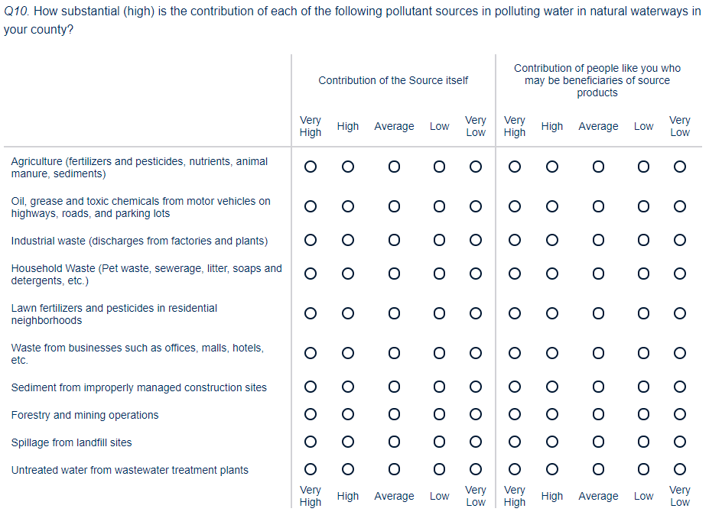

# **SECTION II: CHOICE QUESTIONS**

**Deciding Future Actions**

Imagine that you were given the opportunity to vote on water pollution reduction or water quality improvement programs. Local, state and federal policy makers, under existing legal guidelines, will use your votes from this survey and the votes from others as input to choose the best possible program to improve quality of water in natural waterways (streams, rivers, and lakes) through future policy decisions.

It is important that you carefully consider how you might actually vote if the choice was in a binding referendum. If implemented, these programs might cost your household different amounts of money in the form of an increase in your household’s taxes. Please assume that any taxes would be dedicated to only be used for the changes or outcomes described in a particular choice set. This dedication would be accomplished, for example, through a taxing approach integrated in the State Constitution of each collaborating state:

**Question 11:** For example, the State of Missouri has established taxes through specific Amendments approved by a public vote of its residents, and these taxes can only be used for the purposes specified in that Amendment. Courts have prevented the Missouri legislature from redirecting such funding to alternative purposes, even in times of budget crisis. Only the voters of the state can change the use of such funds. **Do you view such an approach favorably or unfavorably with regard to establishing a means by which states would participate in a national or regional program for improving water quality?**

|  |  |  |  |  |  |  |  |
| --- | --- | --- | --- | --- | --- | --- | --- |
|  | Extremely favorably (1) | favorably (2) | Somewhat favorably (3) | Neither favorably nor unfavorably (4) | Somewhat unfavorably (5) | Unfavorably (6) | Extremely unfavorably (7) |
| How likely are you to support such a measure |  |  |  |  |  |  |  |

Other households are also being surveyed, so please only think of the costs to your own household when deciding the program, you would prefer. **Please note that these tax increases to households will relate to the share of costs to be paid by residential households, after taxes, regulatory costs, and fines paid by other polluting entities.**

All funds would be transparently managed and spent on water quality improvements through a Trust, for which our public representatives appoint the Trustees based on their qualifications to address water quality decisions. Trustees would be appointed for terms designed to begin under one governor’s term and end after then next gubernatorial election, in order to minimize the potential for political influence.

Please take a look at the illustration below depicting sources of the water pollutants. This illustration will help you think about different sources of pollutants of water in natural waterways

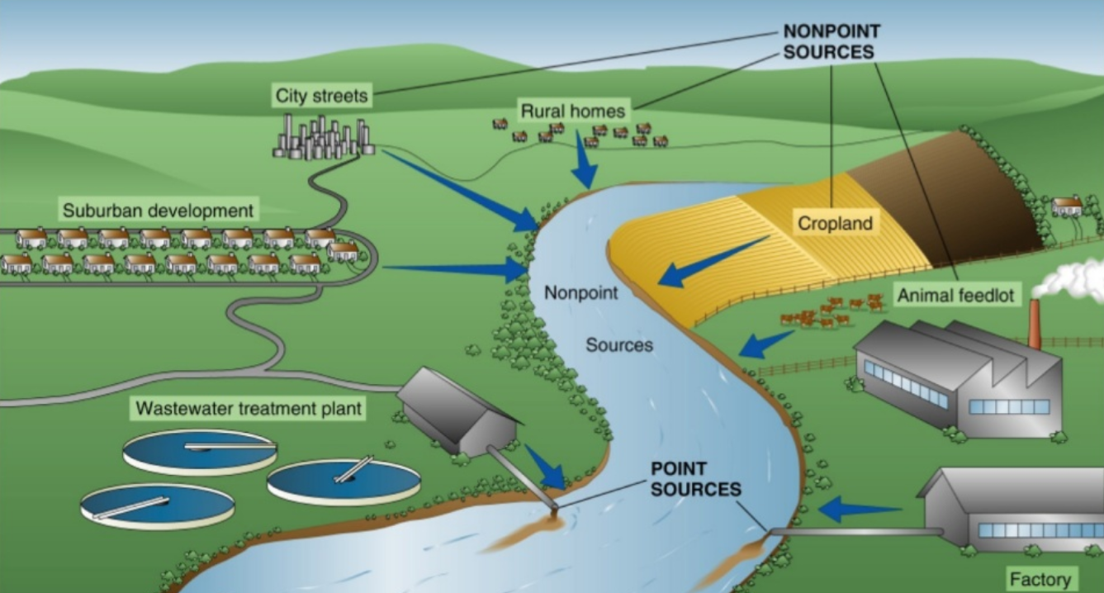

**Q12. What aspect of the Figure do you find most surprising? Least surprising? Not at all surprising?**

|  |  |  |
| --- | --- | --- |
| **Most surprising** | **Least surprising** | **Not at all surprising?** |
|  |  |  |
|  |  |  |
|  |  |  |
|  |  |  |
|  |  |  |
|  |  |  |
|  |  |  |
|  |  |  |

**Q13. In your opinion, how significant is the contribution of ordinary citizens, through goods and services purchased or consumed and daily activities, in adding pollutants to natural waterways?**

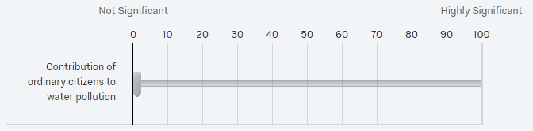

Figure: Sources of water pollutants by share of pollution contribution and extent of regulation. The shares are based on a study conducted in a major waterway in North-Atlantic region of the United States. (Taller bars indicate greater contribution to adding pollutants)

**In your opinion, do the choices regular people make in their day-to-day life (e.g. through goods and services purchased or consumed and daily activities, etc.) significantly impact the quality of water in natural waterways?**



**Water Quality scale based on suitability for human use or recreation score.**

There are *minimally acceptable* levels of certain measures at which water quality experts have determined a stream, a river or a lake is *suitable* for boating, fishing, wading, swimming, etc. As the score increases, the waterbody is more suitable for different activities.

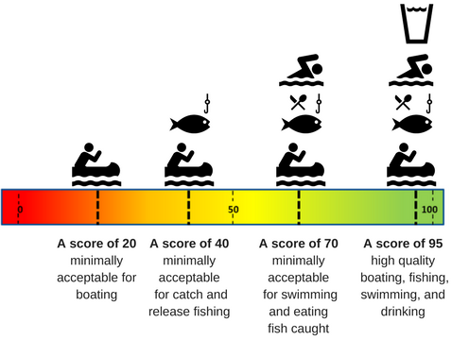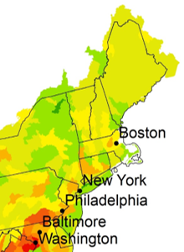 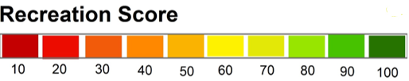

* What is the Recreation Score near your home? _____
* How does that compare with your expectation before seeing the map?
* Lower than you expected
* About the same as you expected
* Higher than you expected

**Water Quality scale based on wildlife/river-life score.**

Scientists can rate the quality of wildlife in wateways by combining measures related to the variety, abundance, and condition of animal and plant species that live in the water.

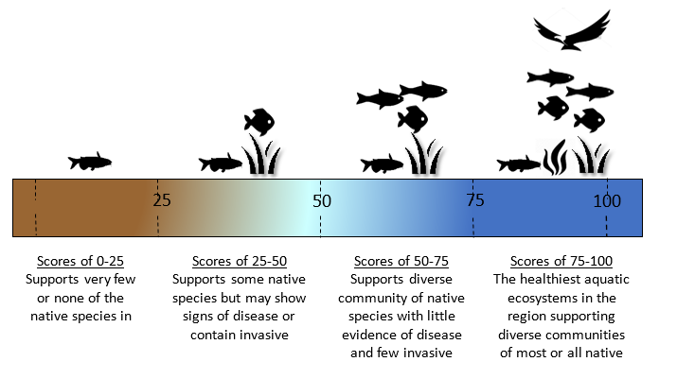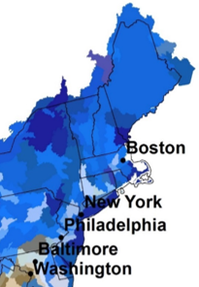

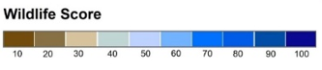

* What is the Wildlife/River-life Score near your home? _____
* How does that compare with your expectation before seeing the map?
* Lower than you expected
* About the same as you expected
* Higher than you expected

|  |  |  |  |
| --- | --- | --- | --- |
|  | **Condition after 10 years** | | |
|  | **No Program** | **Program A** | **Program B** |
| **Percentage of rivers/streams/lakes (area) with score 50 and above**    **Human Use Suitability Score** | 50% of all waterways  (no change) | 60% of all waterways | 70% of all waterways |
| **Percentage of rivers/streams/lakes (area) with score 50 and above**    **Wildlife/river-life Score** | 55% of all waterways  (no change) | 65% of all waterways | 70% of all waterways |
| **Water Clarity**  **Percentage of rivers/streams/lakes (area) with visibility of 2 feet or better** | 50% of all waterways  (no change) | 60% of all waterways | 70% of all waterways |
| **Visible aesthetics**  **Percentage of rivers/streams/lakes with riparian vegetation/ natural buffer zone** | 40 % of all waterways  (no change) | 50% of all waterways | 60% of all waterways |
| **Cost to your household**  Increase in tax that goes into a **fund managed by federal government** to assist farmers or others to improve water quality | **$0**  **Increase in annual federal tax liability** | **$200**  **Increase in annual federal tax liability** | **$300**  **Increase in annual federal tax liability** |
| **Your Vote**  Please mark one of the boxes to the right | **I vote for**  **No Program** | **I vote for**  **Program A** | **I vote for**  **Program B** |

**S2Q1: Please vote for one of the three options below. (***Mark one box at the bottom to indicate which option you would prefer.)* ***PLEASE TREAT CHOICE QUESTIONS ON EACH PAGE INDEPENDENTLY.***

**When answering this choice question, please think about the condition of all water bodies (rivers/streams/lakes) in your county**

|  |  |  |  |
| --- | --- | --- | --- |
|  | **Condition after 10 years** | | |
|  | **No Program** | **Program C** | **Program D** |
| **Out of each 100 miles of waterways so many miles have human use suitability score of 50 and above**    **Human Use Suitability Score** | 55 miles out of each 100 miles (55%) of waterways in your area  (no change) | 65 miles out of each 100 miles (65%) of waterways in your area | 75 miles out of each 100 miles (75%) of waterways in your area |
| **Out of each 100 miles of waterways so many miles have wildlife score of 50 and above**    **Wildlife/river-life Score** | 45 miles out of each 100 miles (45%) of waterways in your area  (no change) | 65 miles out of each 100 miles (65%) of waterways in your area | 80 miles out of each 100 miles (80%) of waterways in your area |
| **Visible aesthetics**  **Proportion of waterways with streamside land in a natural vegetation “buffer zone”** | 50 miles out of each 100 miles (50%) of waterways in your area  (no change) | 60 miles out of each 100 miles (60%) of waterways in your area | 70 miles out of each 100 miles (70%) of waterways in your area |
| **Cost to your household**  Increase in state taxes that goes into a dedicated **fund managed by state government** to assist farmers or others to improve water quality | **$0**  **Increase in annual state tax liability** | **$200**  **Increase in annual state tax liability** | **$500**  **Increase in annual state tax liability** |
| **Your Vote**  Please mark one of the boxes to the right | **I vote for**  **No Program** | **I vote for**  **Program C** | **I vote for**  **Program D** |

**S2Q2: Please vote for one of the three options below. (***Mark one box at the bottom to indicate which option you would prefer.)* ***PLEASE TREAT CHOICE QUESTIONS ON EACH PAGE INDEPENDENTLY.***

**When answering this choice question, please think about the condition of all natural waterways (rivers/streams/lakes) in your county**

**S2Q3: Please vote for one of the two options below. (***Mark one box at the bottom to indicate which option you would prefer.)* ***PLEASE TREAT CHOICE QUESTIONS ON EACH PAGE INDEPENDENTLY.***

**When answering this choice question, please think about the condition of all natural waterways (rivers/streams/lakes) in your county**

|  |  |  |  |
| --- | --- | --- | --- |
|  | **Condition after 10 years** | | |
|  | **Option B**  **(Policy B)** | **Option A**  **(No Policy)** | **Option C**  **(Policy C)** |
| **Recreation Score**  Out of each 100 miles of waterways,  distribution into different level of **human use suitability score** under different policy |  | | |
| **Wildlife Score**  Out of each 100 miles of waterways,  distribution into different level of **wildlife score** under different policy |  | | |
| **Cost to your household**  Increase in tax that goes into a **trust fund managed by a local commission** assist farmers, businesses, and homeowners to implement practices to improve water quality | **$300**  **Increase in annual tax liability** | **$0**  **Increase in annual tax liability** | **$500**  **Increase in annual tax liability** |
| **Your Vote**  Please mark one of the boxes to the right | **I vote for Option B**  **(Policy B)** | **I vote for Option A**  **(No Policy)** | **I vote for Option C**  **(Policy C)** |

**S2Q4: Please vote for one of the two options below. (***Mark one box at the bottom to indicate which option you would prefer.)* ***PLEASE TREAT CHOICE QUESTIONS ON EACH PAGE INDEPENDENTLY.***

**When answering this choice question, please think about the condition of all natural waterways (rivers/streams/lakes) in your county**

|  |  |  |  |
| --- | --- | --- | --- |
|  | **Condition after 10 years** | | |
|  | **Option B**  **(Policy B)** | **Option A**  **(No Policy)** | **Option C**  **(Policy C)** |
| **Recreation Score**  Out of each 100 miles of waterways,  distribution into different level of **human use suitability score** under different policy |  | | |
| **Wildlife Score**  Out of each 100 miles of waterways,  distribution into different level of **wildlife score** under different policy |  | | |
| **Cost to your household**  Increase in tax that goes into a **trust fund managed by a local commission** to assist farmers or others to improve water quality | **$400**  **Increase in annual local tax liability** | **$0**  **Increase in annual tax liability** | **$200**  **Increase in annual local tax liability** |
| **Your Vote**  Please mark one of the boxes to the right | **I vote for Option B**  **(Policy B)** | **I vote for Option A**  **(No Policy)** | **I vote for Option C**  **(Policy C)** |

**S2Q5: Please vote for one of the two options below. (***Mark one box at the bottom to indicate which option you would prefer.)* ***PLEASE TREAT CHOICE QUESTIONS ON EACH PAGE INDEPENDENTLY.***

**When answering this choice question, please think about the condition of all natural waterways (rivers/streams/lakes) in your county**

|  |  |  |  |
| --- | --- | --- | --- |
|  | **Condition after 10 years** | | |
|  | **Option A**  **(Policy A)** | **Option B**  **(No Policy)** | **Option C**  **(Policy C)** |
| **Recreation Score**  Out of each 100 miles of waterways,  distribution into different level of **human use suitability score** under different policy |  | | |
| **Wildlife Score**  Out of each 100 miles of waterways,  distribution into different level of **wildlife score** under different policy |  | | |
| **Cost to your household**  Your household’s annual contribution that supplements fines and taxes paid by other individual and corporate polluters | $400  Increase in **local taxes** that goes into a trust fund managed by a **local commission** | $0  No increase in annual tax liability to your household | $300  Increase in **state taxes** that goes into a trust fund managed by a **state commission** |
| **Your Vote**  Please mark one of the boxes to the right | **I vote for Option A**  **(Policy A)** | **I vote for Option B**  **(No Policy)** | **I vote for Option C**  **(Policy C)** |

**S2Q6: Please vote for one of the two options below. (***Mark one box at the bottom to indicate which option you would prefer.)* ***PLEASE TREAT CHOICE QUESTIONS ON EACH PAGE INDEPENDENTLY.***

**When answering this choice question, please think about the condition of all water bodies (rivers/streams/lakes) in your county**

|  |  |  |
| --- | --- | --- |
|  | **Condition after 5 years** | |
|  | **Option B (No Policy)** | **Option A (Policy A)** |
| **Out of each 100 miles of rivers/streams/lakeshore these many miles of waterbodies with different level of human use suitability score** |  | |
| **Out of each 100 miles of rivers/streams/lakeshore these many miles of waterbodies with different level of wildlife score** |  | |
| **Cost to your household**  Increase in tax that goes into a **fund managed by state government** to assist farmers, businesses, and homeowners to implement practices to improve water quality | **$0**  **Increase in annual tax liability** | **$600**  **Increase in annual tax liability** |
| **Your Vote**  Please mark one of the boxes to the right | **I vote for Option B**  **(No Policy)** | **I vote for Option A**  **(Policy A)** |

# **SECTION III (a): PREFERENCES / FOLLOWUP QUSTIONS:**

**Now we would like to know what you think about river/environmental conservation in general (next page)**

**S3A: Please rate how much you agree or disagree with the following statements. (Please circle one number for each statement.)**

|  |  |  |  |  |  |  |  |  |
| --- | --- | --- | --- | --- | --- | --- | --- | --- |
|  | Strongly disagree (1) | Disagree (2) | | Somewhat disagree (3) | Neither agree nor disagree (4) | Somewhat agree (5) | Agree (6) | Strongly agree (7) |
| 1. I/we think conservation of water bodies is important |  |  | |  |  |  |  |  |
| 2.The federal government should pay for conservation of freshwater bodies |  |  | |  |  |  |  |  |
| 3. Local governments should pay for conservation of freshwater bodies |  |  | |  |  |  |  |  |
| 4. Polluting entities/companies should pay for conservation of water bodies |  |  | |  |  |  |  |  |
| 5. My use of water bodies has been affected because of degradation of water bodies |  |  | |  |  |  |  |  |
|  | Strongly disagree (1) | | Disagree (2) | Somewhat disagree (3) | Neither agree nor disagree (4) | Somewhat agree (5) | Agree (6) | Strongly agree (7) | |
| 6. It is important for our generation to protect the environment and water bodies for future generations |  |  | |  |  |  |  |  |
| 7. Clean water bodies will have significant positive impact on the quality of life of members of this community |  |  | |  |  |  |  |  |
| 8. I /we think the water bodies should be conserved, but we are not willing to pay for it |  |  | |  |  |  |  |  |
| 9. Only those who use the water bodies regularly should pay for their conservation |  |  | |  |  |  |  |  |
| 10. I think that conservation of rivers and streams in this area mostly benefits communities downstream. |  |  | |  |  |  |  |  |
|  | Strongly disagree (1) | | Disagree (2) | Somewhat disagree (3) | Neither agree nor disagree (4) | Somewhat agree (5) | Agree (6) | Strongly agree (7) | |
| 11. I am willing to help communities upstream from where I live to do better to protect water quality in rivers and streams |  |  | |  |  |  |  |  |
| 12. It is important to me personally that rivers and streams have water quality that supports natural ecosystems that are typical of the area where I live. |  |  | |  |  |  |  |  |
| 13. It is important to me personally that the water quality in rivers and streams flowing from my community not create a burden on communities downstream. |  |  | |  |  |  |  |  |

# **SECTION III (b): FOLLOWUP QUSTIONS:**

**S3B: Please rate how much you agree or disagree with the following statements. (Please circle one number for each statement.)**

|  |  |  |  |  |  |  |  |
| --- | --- | --- | --- | --- | --- | --- | --- |
|  | Strongly Disagree (1) | Disagree (2) | Somewhat disagree (3) | Neither agree nor disagree (4) | Somewhat agree (5) | Agree (6) | Strongly agree (7) |
| I voted as if my household would actually face the costs shown in the questions. |  |  |  |  |  |  |  |
| I do not trust the government to make proper use of tax money. |  |  |  |  |  |  |  |
| I voted as if the programs would actually achieve the results shown by 10 years. |  |  |  |  |  |  |  |
| I think there are many things government could stop doing in order to find more money for these water quality programs. |  |  |  |  |  |  |  |
| I am against any regulations and more government spending. |  |  |  |  |  |  |  |
| My household should not have to pay any amount to improve water quality in rivers, streams, and lakes. |  |  |  |  |  |  |  |
| I would like to see the water quality in many natural waterways improved, but I cannot afford to pay for the types of plans shown |  |  |  |  |  |  |  |
| I think the attribute/choice levels presented in this survey were within reasonable bounds |  |  |  |  |  |  |  |
| I believe that expenditure in improvement of water resources is not a priority for my community |  |  |  |  |  |  |  |
| My family and I are satisfied with the water quality in the streams and rivers near us today |  |  |  |  |  |  |  |
| The change is too small to be of importance |  |  |  |  |  |  |  |
| Polluting companies should be made to pay for improvement in rivers, not the public. |  |  |  |  |  |  |  |
| I answered the questions without giving much thought because of time constraint |  |  |  |  |  |  |  |
|  | Strongly Disagree (1) | Disagree (2) | Somewhat disagree (3) | Neither agree nor disagree (4) | Somewhat agree (5) | Agree (6) | Strongly agree (7) |

# **SECTION IV: DEMOGRAPHICS**

**Before finishing the survey, we would like you to answer a few questions relating to you and your household. Remember, these responses will be kept strictly confidential and will NOT be used for identifying any single individual/household nor will they be reported to any other private or governmental entities. Only summary of anonymized aggregated statistics will be made public.**

**S4_Q1. What is your gender?**

* Male (1)
* Female (2)
* Other (3)

**S4_Q2. What is your age (in years)?**

-------------------------------

**S4_Q3. What is the size of your household?**

-------------------------------

**S4_Q4. How many children under age 18 are living in your household?**

-------------------------------

**S4_Q5. What is your employment status?**

* Employed full time (1)
* Employed part time (2)
* Unemployed looking for work (3)
* Unemployed not looking for work (4)
* Retired (5)
* Student (6)
* Disabled (7)
* Other (8)

**S4_Q6. What is your occupation (for full-time or part-time employed individuals)?**

* 11- Management (1)
* 13- Business and Financial Operations occupations (2)
* 15- Computer and Mathematical occupations (3)
* 17- Architecture and Engineering (4)
* 19- Life, Physical, and Social Science (5)
* 21- Community and Social Services (6)
* 23- Legal (7)
* 25- Education, Training, and Library (8)
* 27- Arts, Design, Entertainment, Sports, and Media (9)
* 29- Healthcare Practitioners and Technical (10)
* 31- Healthcare Support (11)
* 33- Protective Service (12)
* 35- Food Preparation and Serving Related (13)
* 37- Building and Grounds Cleaning and Maintenance (14)
* 39- Personal Care and Service (15)
* 41- Sales and Related (16)
* 43- Office and Administrative Support (17)
* 45- Farming, Fishing, and Forestry (18)
* 47- Construction and Extraction (19)
* 49- Installation, Maintenance, and Repair (20)
* 51- Production (21)
* 53- Transportation and Material Moving (22)
* 55- Military Specific (23)

**S4_Q7. Have you or any member of your family ever worked in any of the following industries or jobs?**

* Agriculture/Farming (1)
* Fishing related (2)
* Environmental protection (3)
* Extraction/mining related (4)
* Tourism (5)
* None of these (6)

**S4_Q8. In 2016, what was your total pre-tax household income, including all earners in your household (in thousands of US dollar)?**

Below 25,000

25,00 to 50,000

50,000 to 75,000

75,000 to 100,000

100,000 to 250,000

250,000 to 500,000

Above 500,000

**S4_Q9. What is your race/ethnicity?**

* Native American (1)
* White (2)
* Black or African American (3)
* Hispanic (4)
* Asian (5)
* Other (6)

**S4_Q10. What is the highest degree or level of schooling you have completed?**

* Elementary or high school, but no high school diploma or GED (1)
* High school diploma, GED, or other high school completion (2)
* Some college credit, no degree (3)
* Associate’s degree (for example: AA, AS) (4)
* Bachelor’s degree (for example: BA, BS) (5)
* Master’s degree, professional degree, or doctorate degree (for example: MA, MSW, MD, DDS, JD, PhD, EdD) (6)

**S4_Q11. Do you own a house?**

* Yes (1)
* No (2)

Skip To: S4_Q13 If Do you own a house? = No

**S4_Q12. What do you think is the current market valuation of your home/property?**

--------------------------------------------

**S4_Q13. Are you currently living in your own house?**

* Yes (1)
* No, living in a rental house/ apartment (2)
* No, other (3)

**S4_Q14. What is your monthly rental payment (or what would be rental payment if you were renting your current dwelling)?**

--------------------------------------------

**S4_Q15. What is the main source of drinking water in your household? (check all that apply)**

* Private well (groundwater) (1)
* Public water supply (sourced from municipal groundwater wells) (2)
* Public water supply (sourced from surface waters, such as a natural waterway (3)
* Public water supply but I don’t know whether the source is groundwater or surface water (4)
* Public or private supply supplemented with bottled water (5)
* Exclusively bottled water (6)