# Version: July 10, 2018

# **Water Quality Valuation Study**

This survey asks you about quality of water in fresh-water bodies such as rivers, streams, and lakes in and around your county. Through this survey, we would like to understand what you think about the quality of water in these water bodies and how important potential changes in the quality of water in rivers and streams are to you and your household. Please answer all the questions in this survey thoughtfully.

# Related imageImage result for epa logo

# **SECTION I: GENERAL BACKGROUND QUESTIONS**

**S1_Q1. What is the closest water body from your home (primary residence)?**

* River (1)
* Stream (2)
* Lake/Pond (3)
* Canal (4)
* Ocean (5)
* Other (6)

**S1_Q2a. Approximately, how far is it from your home (distance in miles)?**

--------------------------

**S1_Q2b. Approximately, how far is it from your home (drive time in minutes)?**

--------------------------

**S1_Q3. On average, how often do you see or visit this water body of fresh water?**

* Daily (1)
* Not daily but more than once a week (2)
* Weekly (3)
* Not weekly but more than once a month (4)
* Monthly (5)
* Less than once a month (6)
* Never (7)

**S1_Q4. How do you rate the water quality in the water body closest to your home?**

* Not safe for human use
* Severely polluted
* Boatable
* Fishable but not consumable
* Improved fishing and better catches
* Barely swimmable
* Swimmable better condition
* Drinkable (with minor treatment) and supports all human use

**S1_Q5. How do you rate the quality of this water body for its role in supporting natural ecosystems or fish, wildlife, and native plants?**

* Supports nearly all native species of aquatic life (75-100%)
* Supports a 50-75% of native species
* Supports some native species (25-50%)
* Supports relatively few native species (up to 25%)
* Supports nearly no species (less than 5%)

**S1_Q6. How do you rate the water quality in other water bodies close to your home?**

* Not safe for human use
* Severely polluted
* Boatable
* Fishable but not consumable
* Improved fishing and better catches
* Barely swimmable
* Swimmable better condition
* Drinkable (with minor treatment) and supports all human use

**S1_Q7. Does your household currently pay any environmentally-related taxes or fees as part of your water, electric or other utility bills?**

* Yes (1) If yes, please describe them: ______________________________________________________
* No (2)
* Don't know (999)

**S1_Q8. In the past year, did you participate in any recreational activity at or near the closest natural water body from your house? (please check all that apply)**

* No, I did not participate in recreational activity in or near the closest water body (0)
* Yes, Hiking/Walking (1)
* Yes, Swimming (2)
* Yes, Wading (3)
* Yes, Wildlife viewing (4)
* Yes, Boating/canoeing/kayaking (5)
* Yes, Picnicking (6)
* Yes, Fishing (7)
* Yes, Other_______________ (8)

**S1_Q9. In the past year, did you participate in any recreational activity at or near any natural water body? (please check all that apply)**

* No, I did not participate in recreational activity in or near water bodies (0)
* Yes, Hiking/Walking (1)
* Yes, Swimming (2)
* Yes, Wildlife viewing (3)
* Yes, Boating/canoeing/kayaking (4)
* Yes, Picnicking (5)
* Yes, Fishing (6)
* Yes, Other_______________ (7)

**S1_Q10. What is the source of Drinking water in your household?**

* Private well (1)
* Public water supply (2)
* Other (e.g. bottled water) _____________ (3)

**S1_Q11. What do you think is the main source of pollutants of water in rivers, streams or lakes in your area?**

* Industrial waste (1)
* farming waste (2)
* residential waste (3)
* spillage from landfill sites (4)
* Other ----------------------(4a)
* ----------------------(4b)
* ----------------------(4c)

# **SECTION II: CHOICE QUESTIONS**

**Deciding Future Actions**

Imagine that you were given the opportunity to vote on water pollution reduction or water quality improvement programs. State and federal policy makers will use your votes and votes from others to choose the best program to improve water quality, including through completion of this survey.

**Important instructions**

In the questions that follow, we ask your opinion about programs that have different impacts on rivers, streams, and lakes in your county, state, or region. These programs will cost your household different amounts of money in the form of an increase in your household’s taxes.

You will be asked several questions. Please treat all questions independently. Each question asks you to vote for the option you like best from three different alternatives:

One of the options keeps all current actions but does not add new programs. Choosing the “no action” option in each question would result in no new pollution reductions and no new tax costs to your household.

The other option(s) include additional programs to improve water quality in water bodies near you, with different environmental outcomes and tax costs to your household.

Other households are also being surveyed, so please only think of the costs to your own household when deciding which program you would prefer.

Similar studies have shown that people sometimes respond differently in a survey than they would in real life, often saying (in the survey) that they would pay more than they really would. **When voting we urge you to respond as though costs to your household would really go up if the program were implemented. Input from this survey will contribute to decisions that U.S. EPA makes under the Clean Water Act and related regulatory authority.**

|  |
| --- |
| **Sources of Degradation of Water Quality**  Pollutants of water in rivers, streams or lakes include sediment, nutrients, and chemical contaminants. Processes that degrade waters include habitat modification (such as destruction of streamside vegetation) and hydrologic modification (such as flow reduction). Indicators of water quality degradation include physical, chemical, and biological parameters. Examples of biological parameters include species diversity and abundance of species. Examples of physical and chemical parameters include clarity, acidity and temperature. Following are descriptions of the effects of the pollutants and processes most commonly identified in rivers, streams, lakes, and wetlands.  **Nutrients** include nitrates found in sewage and fertilizers and phosphates found in detergents and fertilizers. In excess levels, nutrients overstimulate the growth of aquatic plants and algae. Excessive growth of these organisms, in turn, can clog navigable waters, use up dissolved oxygen as they decompose, and block light to deeper waters  **Silt and other suspended solids** wash off plowed fields, construction and logging sites, urban areas, strip-mined land, and eroded stream banks when it rains. More suspended solids decreases water clarity. As these sediments enter rivers and lakes, habit of aquatic organisms is affected, and our aesthetic enjoyment of the water is reduced.  **Pathogens** (certain waterborne bacteria, viruses, and protozoans) can cause human illnesses that range from typhoid and dysentery to minor respiratory and skin infections or rashes.  **Organic material** may enter waterways in many different forms as sewage, as leaves and grass clippings, or as runoff from livestock feedlots and pastures.  **Metals** (such as mercury, lead, and cadmium) and toxic organic chemicals (such as PCBs and dioxin) may originate in industrial discharges, runoff from city streets, mining activities, leachate from landfills, and a variety of other sources  **Pesticides and herbicides** used on croplands, lawns, and in termite control can be washed into ground and surface waters by rainfall, snowmelt, and irrigation practices  Source: Environmental Protection Agency (https://goo.gl/wm8c4T) |

|  |
| --- |
| **Water Clarity**  Water clarity provides a visual indication of the condition of water. Water clarity is a measure of how far down light can penetrate through the water column. Clear waters are characterized by low concentrations of suspended soil particles and/or algae. Because water clarity is closely related to light penetration, it has important implications for the diversity and productivity of aquatic life that a system can support.  Water clarity is affected by a number of physical, chemical and biological factors that are connected to the natural geology and human use of the surrounding lands within the watershed. Some waters are naturally turbid. However, waters that receive excessive inputs of nutrients (such as fertilizer runoff) and sediments (for example, from construction runoff) are generally less clear and more turbid.  Source: National Aquatic Resource Surveys, EPA |

**Water Quality scale based on suitability for human use or recreation score.** Please consider the following scale infographics while answering questions referring to human use suitability or **recreation score** for water quality.

There are *minimally acceptable* levels of certain measures at which water quality experts have determined a lake or river is *suitable* for boating, fishing or swimming.

Some of those measures are:

Fecal coliform - bacteria from sewage

Dissolved oxygen – the amount of oxygen in the water

Turbidity - water clarity

All of those measures can be combined to create a single score. As the score increases, the waterbody is more suitable for different activities.

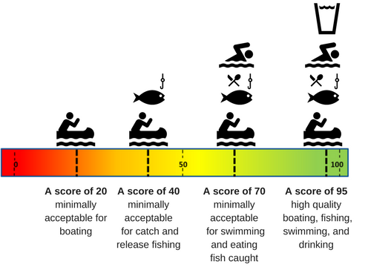

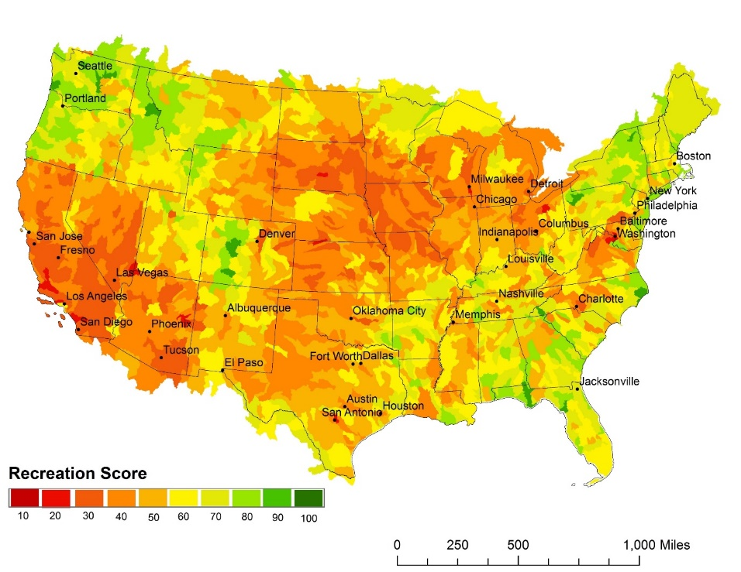

**Water Quality scale based on wildlife/river-life score.** Please consider the following scale infographics while answering questions referring to **wildlife/river-life** score for water quality.

Scientists can rate the health of an aquatic ecosystem by combining measures related to the variety, abundance, and condition of animal and plant species that live in the water.

Some of those measures are

* + Species richness - the number of native aquatic species
  + Food web composition - the correct balance of plant-eaters and predators
  + Species condition - free of invasive species and disease

Each measure at a site is compared to a *reference site* that is in the same region but has very little influence from human activities.  The closer a measure at a waterbody is to the reference site, the higher the rating it receives for that measure.

These individual ratings are then combined to give an overall score of *wildlife/riverlife health*.

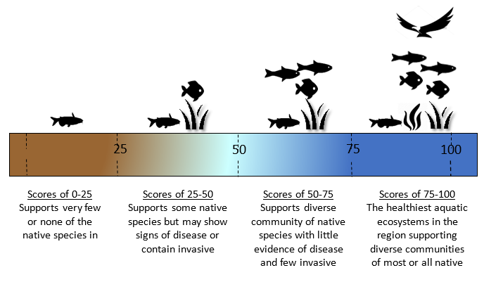

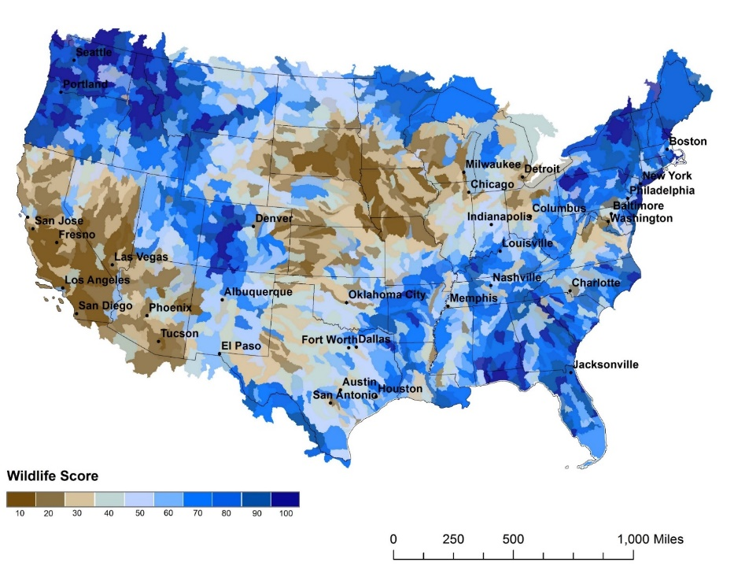

|  |  |  |  |
| --- | --- | --- | --- |
|  | **Condition after 10 years** | | |
|  | **No Program** | **Program A** | **Program B** |
| **Percentage of rivers/streams/lakes (area) with score 50 and above**    **Human Use Suitability Score** | 50%  (no change) | 60% | 70% |
| **Percentage of rivers/streams/lakes (area) with score 50 and above**    **Wildlife/river-life Score** | 55%  (no change) | 65% | 70% |
| **Water Clarity**  **Percentage of rivers/streams/lakes (area) with visibility of 2 feet or better** | 50%  (no change) | 60% | 70% |
| **Visible aesthetics**  **Percentage of rivers/streams/lakes with riparian vegetation/ natural buffer zone** | 40 %  (no change) | 50% | 60% |
| **Cost to your household**  **Increase in annual tax payments for your household** | **$0**  **Increase in annual tax liability** | **$100**  **Increase in annual tax liability** | **$200**  **Increase in annual tax liability** |
| **Your Vote**  Please mark one of the boxes to the right | **I vote for**  **Option A** | **I vote for**  **Option B** | **I vote for**  **Option C** |

**S2Q1: Please vote for one of the three options below. (***Mark one box at the bottom to indicate which option you would prefer.)*

**When answering this choice question, please think about the condition of all water bodies (rivers/streams/lakes) in your county**

|  |  |  |  |
| --- | --- | --- | --- |
|  | **Condition after 10 years** | | |
|  | **No Program** | **Program C** | **Program D** |
| **Out of 100 miles of rivers/streams/lakeshore so many miles have human use suitability score of 50 and above**    **Human Use Suitability Score** | 50 miles out of 100 miles  (no change) | 60 miles out of 100 miles | 70 miles out of 100 miles |
| **Out of 100 miles of rivers/streams/lakeshore so many miles have wildlife score of 50 and above**    **Wildlife/river-life Score** | 55 miles out of 100 miles  (no change | 65 miles out of 100 miles | 70 miles out of 100 miles |
| **Visible aesthetics**  **Percentage of rivers/streams/lakes with riparian vegetation/ natural buffer zone** | 40 miles out of 100 miles  (no change) | 50 miles out of 100 miles | 60 miles out of 100 miles |
| **Cost to your household**  **Increase in annual tax payments for your household** | **$0**  **Increase in annual tax liability** | **$100**  **Increase in annual tax liability** | **$200**  **Increase in annual tax liability** |
| **Your Vote**  Please mark one of the boxes to the right | **I vote for**  **Option A** | **I vote for**  **Option B** | **I vote for**  **Option C** |

**S2Q2: Please vote for one of the three options below. (***Mark one box at the bottom to indicate which option you would prefer.)*

**When answering this choice question, please think about the condition of all water bodies (rivers/streams/lakes) in your county**

**S2Q3: Please vote for one of the two options below. (***Mark one box at the bottom to indicate which option you would prefer.)***When answering this choice question, please think about the condition of all water bodies (rivers/streams/lakes) in your county**

|  |  |  |
| --- | --- | --- |
|  | **Condition after 10 years** | |
|  | **No Policy** | **With Policy** |
| **Out of 100 miles of rivers/streams/lakeshore these many miles of waterbodies with different level of human use suitability score** |  |  |
| **Out of 100 miles of rivers/streams/lakeshore these many miles of waterbodies with different level of wildlife score** |  |  |
| **Cost to your household**  **Increase in tax that goes into a fund to pay for farmers or others to improve water quality** | **$0**  **Increase in annual tax liability** | **$150**  **Increase in annual tax liability** |
| **Your Vote**  Please mark one of the boxes to the right | **Option A**  **I vote for no policy** | **Option B**  **I vote for policy** |

**S2Q4: Please vote for one of the two options below. (***Mark one box at the bottom to indicate which option you would prefer.)*

**When answering this choice question, please think about the condition of all water bodies (rivers/streams/lakes) in your county**

|  |  |  |
| --- | --- | --- |
|  | **Condition after 10 years** | |
|  | **No Policy** | **With Policy** |
| **Out of 100 miles of rivers/streams/lakeshore these many miles of waterbodies with different level of human use suitability score** |  | |
| **Out of 100 miles of rivers/streams/lakeshore these many miles of waterbodies with different level of wildlife score** |  | |
| **Cost to your household**  **Increase in annual tax payments for your household** | **$0**  **Increase in annual tax liability** | **$100**  **Increase in annual tax liability** |
| **Your Vote**  Please mark one of the boxes to the right | **Option A**  **I vote for no policy** | **Option B**  **I vote for policy** |

# **SECTION III (a): PREFERENCES / FOLLOWUP QUSTIONS:**

**Now we would like to know what you think about river/environmental conservation in general (next page)**

**S3A: Please rate how much you agree or disagree with the following statements. (Please circle one number for each statement.)**

|  |  |  |  |  |  |  |  |
| --- | --- | --- | --- | --- | --- | --- | --- |
|  | Strongly disagree (1) | Disagree (2) | Somewhat disagree (3) | Neither agree nor disagree (4) | Somewhat agree (5) | Agree (6) | Strongly agree (7) |
| 1. I/we think conservation of water bodies is important |  |  |  |  |  |  |  |
| 2.The federal government should pay for conservation of freshwater bodies |  |  |  |  |  |  |  |
| 3. Local governments should pay for conservation of freshwater bodies |  |  |  |  |  |  |  |
| 4. Polluting entities/companies should pay for conservation of water bodies |  |  |  |  |  |  |  |
| 5. My use of water bodies has been affected because of degradation of water bodies |  |  |  |  |  |  |  |
| 6. It is important for our generation to protect the environment and water bodies for future generations |  |  |  |  |  |  |  |
| 7. Clean water bodies will have significant positive impact on the quality of life of members of this community |  |  |  |  |  |  |  |
| 8. I /we think the water bodies should be conserved, but we are not willing to pay for it |  |  |  |  |  |  |  |
| 9. Only those who use the water bodies regularly should pay for their conservation |  |  |  |  |  |  |  |
| 10. I think that conservation of rivers and streams in this area mostly benefits communities downstream. |  |  |  |  |  |  |  |
| 11. I am willing to help communities upstream from where I live to do better to protect water quality in rivers and streams |  |  |  |  |  |  |  |
| 12. It is important to me personally that rivers and streams have water quality that supports natural ecosystems that are typical of the area where I live. |  |  |  |  |  |  |  |
| 13. It is important to me personally that the water quality in rivers and streams flowing from my community not create a burden on communities downstream. |  |  |  |  |  |  |  |

# **SECTION III (b): FOLLOWUP QUSTIONS:**

**WTP follow-up questions to determine valid responses Possible reasons for unwillingness to pay**

**S3B: Please rate how much you agree or disagree with the following statements. (Please circle one number for each statement.)**

|  |  |  |  |  |  |  |  |
| --- | --- | --- | --- | --- | --- | --- | --- |
|  | Strongly Disagree (1) | Disagree (2) | Somewhat disagree (3) | Neither agree nor disagree (4) | Somewhat agree (5) | Agree (6) | Strongly agree (7) |
| I voted as if my household would actually face the costs shown in the questions. |  |  |  |  |  |  |  |
| I do not trust the government to make proper use of tax money. |  |  |  |  |  |  |  |
| I voted as if the programs would actually achieve the results shown by 10 years. |  |  |  |  |  |  |  |
| I would vote differently if the programs took longer to achieve the results shown. |  |  |  |  |  |  |  |
| I am against any regulations and more government spending. |  |  |  |  |  |  |  |
| My household should not have to pay any amount to improve water quality in rivers, streams, and lakes. |  |  |  |  |  |  |  |
| It is important to improve waters in this area, no matter how high the costs. |  |  |  |  |  |  |  |
| I think the attribute/choice levels presented in this survey were within reasonable bounds |  |  |  |  |  |  |  |
| I believe that expenditure in improvement of water resources is not a priority for my community |  |  |  |  |  |  |  |
| Me and my family are not very interested in this matter |  |  |  |  |  |  |  |
| The change is too small to be of importance |  |  |  |  |  |  |  |
| Polluting companies should be made to pay for improvement in rivers, not public. |  |  |  |  |  |  |  |
| I answered the questions without giving much thought because of time constraint |  |  |  |  |  |  |  |

# **SECTION IV: DEMOGRAPHICS**

**Before finishing the survey, we would like you to answer a few questions relating to demographics of you and your household. Remember, these responses will kept strictly confidential and will NOT used for identifying any single individual/household nor will they be reported to any other private or governmental entities.**

**S4_Q1. What is your gender?**

* Male (1)
* Female (2)
* Other (3)

**S4_Q2. What is your age (in years)?**

-------------------------------

**S4_Q3. What is the size of your household?**

-------------------------------

**S4_Q4. How many children under age 18 are living in your household?**

-------------------------------

**S4_Q5. What is your employment status?**

* Employed full time (1)
* Employed part time (2)
* Unemployed looking for work (3)
* Unemployed not looking for work (4)
* Retired (5)
* Student (6)
* Disabled (7)
* Other (8)

**S4_Q6. What is your occupation (for full-time or part-time employed individuals) ?**

* 11- Management (1)
* 13- Business and Financial Operations (2)
* 15- Computer and Mathematical (3)
* 17- Architecture and Engineering (4)
* 19- Life, Physical, and Social Science (5)
* 21- Community and Social Services (6)
* 23- Legal (7)
* 25- Education, Training, and Library (8)
* 27- Arts, Design, Entertainment, Sports, and Media (9)
* 29- Healthcare Practitioners and Technical (10)
* 31- Healthcare Support (11)
* 33- Protective Service (12)
* 35- Food Preparation and Serving Related (13)
* 37- Building and Grounds Cleaning and Maintenance (14)
* 39- Personal Care and Service (15)
* 41- Sales and Related (16)
* 43- Office and Administrative Support (17)
* 45- Farming, Fishing, and Forestry (18)
* 47- Construction and Extraction (19)
* 49- Installation, Maintenance, and Repair (20)
* 51- Production (21)
* 53- Transportation and Material Moving (22)
* 55- Military Specific (23)

**S4_Q7. Have you or any member of your family ever worked in any of the following industries or jobs?**

* Agriculture/Farming (1)
* Fishing related (2)
* Environmental protection (3)
* Extraction/mining related (4)
* Tourism (5)
* None of these (6)

**S4_Q8. In 2016, what was your total pre-tax household income, including all earners in your household (in thousands of US dollar)?**

Below 25,000

25,00 to 50,000

50,000 to 75,000

75,000 to 100,000

100,000 to 250,000

250,000 to 500,000

Above 500,000

**S4_Q9. What is your race/ethnicity?**

* Native American (1)
* White (2)
* Black or African American (3)
* Hispanic (4)
* Asian (5)
* Other (6)

**S4_Q10. What is the highest degree or level of schooling you have completed?**

* Elementary or high school, but no high school diploma or GED (1)
* High school diploma, GED, or other high school completion (2)
* Some college credit, no degree (3)
* Associate’s degree (for example: AA, AS) (4)
* Bachelor’s degree (for example: BA, BS) (5)
* Master’s degree, professional degree, or doctorate degree (for example: MA, MSW, MD, DDS, JD, PhD, EdD) (6)

**S4_Q11. Do you own a house?**

* Yes (1)
* No (2)

Skip To: S4_Q13 If Do you own a house? = No

**S4_Q12. What do you think is the current market valuation of your home/property?**

--------------------------------------------

**S4_Q13. Are you currently living in your own house?**

* Yes (1)
* No, living in a rental house/ apartment (2)
* No, other (3)

**S4_Q14. What is your monthly rental payment (or what would be rental payment if you were renting your current dwelling)?**

--------------------------------------------